Building Towards the Championships
Mike Long
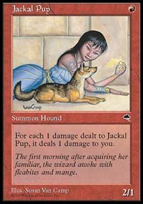
We've all heard stories of creative multi-color Standard decks, rumors of tournaments being dominated by clever players who didn't even own computers and strategies refined over the weeks and the months before a cool deck emerged.
Then came Necro, the Dojo and finally Tempest. Then, the first commandment was: "thy deck shall be one color and one color only. Otherwise thou shalt choke to death on Jackal Pups and Wastelands and Ball Lightnings." Urza's Block made things even worse with second and third turn kills, leaving little time to play one color, much less three.
Invasion brings the promise of new possibilities and fresh decks. We now have dual lands that don't cause pain, plus dozens of gold cards, many of which are actually good. Combine that with the passing of a whole host of overpowered cards - Tinker, Masticore, Rancor, Gaea's Cradle, Grim Monolith, etc - and things get interesting.

Combining with Green with White is as good now as it was in the days when pudgy social workers could win a Pro Tour...
I'm really looking forward to Invasion filling the void left by Urza's Block. Starkly different decks should emerge, but the only thing we really know is that the times, they are a-changin.
State Championships are our first clear view of the new Standard. If we want to make a good prediction of the States metagame, it's important first to look at what's gone, what's new, and how they will mingle to form the decks that will shine in States, Pro Tour Chicago, the National Championships, and finally Worlds.
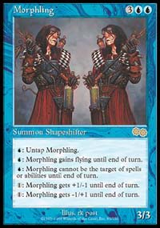
So long, Superman
I began making predictions several months ago looking at my U.S. Nationals deck. I decided to separate my Accelerated Blue deck into two piles: cards that would stay and cards that would go in November. The cards that are still available consisted of Rishadan Port, Brainstorm, Counterspell and Thwart. That was it. Gone were my Masticores, my Morphlings, Treachery, Grim Monoliths, Stroke of Genius and even my lone Palinchron. In all, about a quarter of my non-Islands will be playable! Jon Finkel's World Championship deck fares no better, with Tinker, Voltaic Key, Phyrexian Colossus, and Phyrexian Processors all retiring. In fact almost all of the successful Worlds decks - Stompy, Angry Hermit, Yawgmoth's Will Black, Replenish, and several others - were 50%+ Urza's Block.
Even these retirees were refugees from a massive purge that saw Tolarian Academy, Time Spiral, Memory Jar and several other cards banned. Masticore was necessary play for almost every deck. Most decks relied on either Grim Monolith or Gaea's Cradle to accelerate. The number of bomb cards now gone is staggering; joining the cards mentioned above are Replenish, Opalescence, Duress, Powder Keg, Deranged Hermit, Avalanche Rider, and the "man lands."
So with all those happy cards off to Extended Valhalla, what is left? Here's a brief color-by-color analysis of the better Standard cards still available from Masques Block and 6th Edition:

White
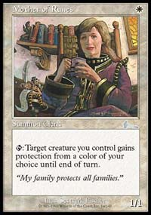
Bye, Mom!
Besides Replenish and Opalescence, white lost very little. White's traditional strength, weenie beatdown, is missing only Mother of Runes (which many aggressive deck builders felt suspect anyway), and the powerful Rebel engine is alive and kicking, with Crusade and Parallax Wave backing the Rebels up.

Blue
Along with White Weenie, Blue decks dominated Masques Block constructed The powerful counter-draw synergy of Daze, Thwart, Foil and Gush is still available, as are power cards like Rising Waters and Parallax Tide. Blue's only major losses are Morphling and Tinker.
Blue has troubles with the support crew though. Masticore, combined creature control and beatdown for the control player, is long gone. Drake Hatchling, Air Elemental, Stinging Barrier and Waterfront Bouncer combined don't pull the 'Core's weight. Plus, there is nothing that provides cheap and easy mass removal like Blue's second favorite artifact: Powder Keg.

Black
Black was devastated by losses, missing the recursion of Yawgmoth's Will, creature threats such as Skittering Skirge and Phyrexian Negator, disruption like Duress and utility cards Persecute, Eradicate and Corrupt.
Still Black has Vampiric Tutor, which creates a lot of opportunities, as does the underrated Unmask. The only viable creatures at Black's wins seem to be fragile Mercenaries and the pestilence beast, Thrashing Wumpus.

Red
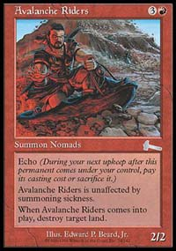
See ya, Darwin!
Red lost little and looks very strong. The only notable departures are Avalanche Rider, Wildfire, and Ghitu Encampment. Shock, Seal of Fire, Earthquake, Cave In, Stone Rain, Pillage and Tectonic Break are still around to bring the pain. Look for some neat Red decks to come about.

Green
With Pouncing Jaguar, Albino Troll and Wild Dog off to Extended, has Green been usurped as beatdown king? Is Green the red-headed stepchild again? Stompy may be the last all or nothing beatdown deck we see for a while. It's 2 power/1 mana creatures are gone, and they carried off Rancor with them.
Still River Boa, probably the best two casting cost creature ever, will find it's way into decks, as will the mighty Blastoderm/Saproling Burst duo that won so many MBC matches.

Artifacts
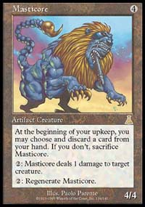
Auf Wiedersehen, Masticore!
For the last two years the deck played by the World Champion has been at least 1/3 artifact cards. No more. Gone is Masticore, maybe the most important artifact ever printed, along with Grim Monolith, Voltaic Key, Powder Keg, and a host of marginal artifacts.
What's left? Chimeric Idol, Tangle Wire, and the Diamonds are the only artifacts I anticipate seeing much play. Tangle Wire, among the coolest and most confusing cards ever printed (ever tried to explain Wire to someone who hasn't played with it?) is a mystery. Now that decks have less mana acceleration, will Wire be better or worse? It's hard to say as of yet. It's certainly good in creature/Armageddon decks... One thing is for sure: Chimeric Idol will make the cut on many teams. It's strong versus Wrath of God, Earthquake, protection from color, and Teferi's Moat... and it's a 3/3 for 3 that doesn't stop Nether Shadows from oozing up out of the graveyard.

Lands
Gaea's Cradle is the most important loss, followed closely by "man lands," most notably Treetop Village, and Ghitu Encampment.
Rishadan Port is still available, as is Dust Bowl, both of which look painful to a multi-colored deck.

What's New?

White
White seems to get few obvious power cards. Rout (an instant Wrath of God) is interesting, especially with sorcery resistant cards like Chimeric Idol and Skizzik available, but probably just not as efficient as Parallax Wave or Wrath itself.

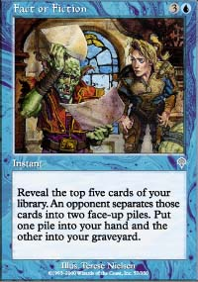
Blue
Of all colors blue looks as if it gained the most. Opt and Fact or Fiction have people buzzing about card motion and advantage. Exclude also raises eyebrows, as Standard looks creature-heavy. A pair of reprints worth noting are Disrupt and Merfolk Traders out of Weatherlight.

Black
Like white, mono-black appears to gain little from Invasion. The most interesting card is probably Yawgmoth's Agenda, an eternal Yawgmoth's Will with a one card per turn drawback that may keep it from being abused.

Red
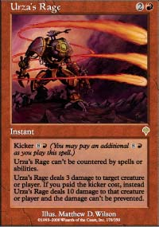
Red gets a pair of interesting cards. Skizzik is a splashable cross between Eron the Relentless and Ball Lightning. Urza's Rage, a Lightning Bolt/Fireball that can't be prevented or countered, will at least make Misdirection more appealing.

Green
As always, green presents us with new creatures to check out. As always, only time will tell which get play and which lurk in your trade binder waiting to ambush cute little kids. Most interesting are the world's fattest Grizzly Bear (Kavu Titan) and the world's most elusive Grizzly Bear (the uncounterable, untargetable Blurred Mongoose). Kavu Chameleon has potential too, being a more powerful update of Scragnoth with a sneaky "you can't Terror me/ I'm goin' on a Crusade!" power attached. Also keep your eye on Utopia Tree and Elvish Champion.

Artifacts
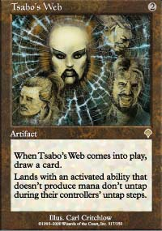
Ports and Dust Bowls look as if they will feast on the multitude of multi-colored decks. But look again, as Teferi's Response and Tsabo's Web present a nasty side effect to playing with powerful lands. Web appears especially dangerous, and will significantly impact Standard. In fact, I find mono-Red Ponza decks more affected by the Web than the loss of Avalanche Rider, Masticore, and Ghitu Encampment put together.

Gold
There are dozens of Gold cards to keep an eye on. Void and Blazing Specter are the kinds of cards you want to build decks around. Absorb and Undermine are both compelling reasons to add an extra color to your counterspell deck, and Recoil may be the Blue/Black Pillage. The new Merfolk are both very powerful (interestingly enough, the Zombie appears to be more useful than the Knight). Sleeper's Robe seems so much better than Curiosity that it is worth an extra black mana. Best of all the Dragons will see play. Big 6/6 flying monsters for 6 mana that have additional devastating effects...not too shabby in my book. Besides, when since Chronicles have you ever played with a dragon legend anyway? Finally, a card that is powerful but will probably have to wait for its day is Teferi's Moat. Currently, with the amount of attention that is being focused on multi-color decks, the benefit of not being whacked by 1/2 or 1/3 or your opponents creatures does not seem all that appealing for a 5-drop multi-color enchantment.

Double Cards
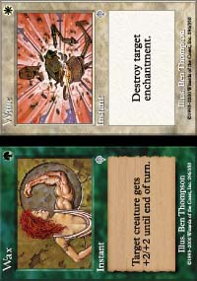
Wax and Wane seems to present a viable alternative to Disenchant for Green/White beatdown, and Assault and Battery seems like an obvious improvement over Shock for Red/Green decks. Only time will tell for the rest of the doubles.

Lands
The new dual lands are just plain good and do what Magic needed: they make it possible to play fun, cool, creative decks.

How Do the Colors Mix?
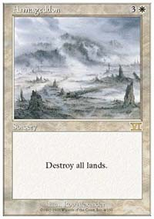
White is one of the easier colors to mix with it's adjoining colors without losing the source of your power, rebels and Parallax Wave backed with Disenchant and Seal of Removal. Though none of the new green/white gold cards appear to be obvious plays, the new dual lands present intriguing possibilities for either Counter-Rebel or a return to Green White beatdown with big Armageddon backup. Ernham Geddon anyone?
Though Blue is probably still the most powerful color, it will be a struggle to build a good blue deck. Why? For starters, Masques Blue relies heavily on Islands to power its alternative casting costs, and adding a second or third color really messes with your Island count. However, the main problem for Blue is not the land. It's how to protect yourself/win the game. Without Masticore and Powder Keg to answer threats, that is a real dilemma. Blue should do very well, but it will take a while for deckbuilders to balance the Masques counter engine and card drawing power of Opt, Accumulated Knowledge, and Fact or Fiction while still having an answer for threats on the table.
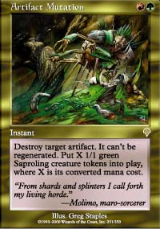
Off the proverbial hook?
The Green power of Masques Block - Blastoderm and Saproling Bursts - remains strong. Combining it with solid standbys like Llanowar Elf, Birds of Paradise, Giant Growths and River Boa certainly seems potent, but alone shouldn't make the cut. Combining with Green with White is as good now as it was in the days when pudgy social workers could win a Pro Tour. As far as Green/Red, the new Stormbind (Meteor Swarm) is intriguing, especially when you consider Squee as fuel. Folks are surely working on a new incarnation of 5-color green, but they'll have to find a new focus for the deck; there's no sleek parallel for Matt Place and his brother's brainstorm with this card pool. With all of the scuttlebutt going around about Chimeric Idols, watch out for Artifact Mutation...it may just be off the proverbial hook.
Red looks like it's in for good times. It should be fairly easy to match new powerful gold-borders to red's efficient core of removal. The most important gold cards from where I sit are Meteor Swarm, Void, and Blazing Specter.
Black- With the possible exception of the surprisingly fast Mercenary deck from MBC, black looks more like a splash color. It can still lend Vampiric Tutor, various Terrors, sideboard hate, and gold cards for blue like Lobotomy, Recoil and Void, plus Thrashing Wumpus is solid if weenie decks prove popular.
Land: The new dual lands combine well with pain lands for a stable mana base. Port and Dust Bowl took a pretty hefty hit, but Kor Haven and Rath's Edge appear to be the real victims of the Web, as the possibility of getting tangled probably makes them too dangerous to play.
Now that we have looked what was taken away from the old Standard with Urza's Block leaving, and what was added with Invasion, we can look forward to the first decks that will define the new Standard. In the next installment, I will detail some of the decks that I have been working with, as well as how they stacked up against other "Dojo-tested, Dojo-approved" decks. Look forward to some new ideas, some new tricks, and as always, some throwbacks to the past revisited with the new sets.

